

Interim Progress Report (IPR)

Project Title: A Comparative Study of Pretrained CNNs for Astronomical Image Classification with Limited Data
Module Title: 7COM1039 – Advanced Computer Science Masters Project
Student Number & Name: Mohammad Umer Khan – 24054795
Supervisor: Kheng Lee Koay
Contents
1. Background Research and Literature Review 3
1.1 Introduction and Project Background 3
1.2 Goals and Objectives 4
1.2.1Overall Project Goal 4
1.2.2 Specific Objectives 4
1.3 Research Questions 5
1.3.1 Sub-Research Questions 5
1.4 Core Research Problem 5
1.5 Literature Review 6
1.5.1 Transfer Learning with Limited Data 6
1.5.2 CNNs in Astronomical Image Classification 6
1.5.3 Challenges and Limitations 7
1.6 Literature–to–Project Mapping 8
2. Summary of Progress to Date 9
2.1 Completed Work to Date 9
2.2 Pending Work and Planned Next Steps 10
3. Consideration of Ethical, Legal, Professional, and Social Issues 11
3.1 Ethical Considerations 11
3.2 Legal Considerations 11
3.3 Professional Considerations 12
3.4 Social Considerations 12
4. Project Plan 13
5. Level of the Project 14
6.Citations 15
7.Appendices 15

Table of Figures
Figure 1 GitHub Repository 16
Figure 2 Dataset 17
Figure 3 Baseline Code Attempt 17
Figure 4 Baseline Code Attempt Results 18
Figure 5 Project Planning Flow Chart 18
Figure 6 Gantt Chart 19

Background Research and Literature Review

Introduction and Project Background
Astronomical imaging has become very important in modern astronomy as advancements in the field and technology have allowed greater access to observational data form ground-based and space telescopes. Automated classification of this data is essential to the field as extracting data individually from these images is infeasible due to the complexity of the data. Convolutional Neural Networks (CNNs) have emerged as highly effective method for image classification including astronomy as they can learn hierarchical spatial features from raw pixel data.
However, applying CNNs to astronomical datasets can present some challenges. Many well-known CNNs, such as ResNet and EfficientNet are pretrained on large natural image datasets like ImageNet, which have different features and visual characteristics than found in celestial images. Additionally, astronomical datasets are often limited in size, highly imbalanced and can contain rare objects or anomalies, making it difficult to train deep networks from scratch without overfitting. To overcome these limitations, transfer learning has emerged as a practical solution in the past few years enabling pretrained models to adapt to new domains that have smaller datasets. Recent studies show transfer learning can result in higher classification performance with limited astronomical data e.g. galaxy morphology classification and rare object detection (Ackermann et al., 2018; MdPI, 2023; Bohrium, 2024).
Despite these successes, there remains open questions regarding the optimal transfer learning strategies for small, domain specific astronomical datasets. Key considerations would include which architecture performs the best under limited data and whether to fine-tune the entire network or to the role of data augmentation to reduce class imbalance in the dataset. Addressing these questions forms the foundation of this project, which aims to systematically compare pretrained CNN architectures and fine-tuning strategies to ass and evaluate their performance and generalization on limited astronomical datasets.

Goals and Objectives

Overall Project Goal
The primary goal of this project is to investigate the effectiveness of transfer learning for astronomical image classification under limited data conditions. The project aims to differentiate which pretrained CNN would perform the best classification on celestial imagery after having different fine-tuning strategies applied to it. The project also wants so to see the generalization capability and computational efficiency that could be achieved through this.

Specific Objectives
- Architecture Comparison
This basically includes the comparison of how different pretrained CNNs perform (e.g ResNet50, VGG16 and EfficientNetB0) when applied to limited astronomical image datasets.
- Fine-Tuning Strategy Evaluation
To investigate the impact of different transfer learning strategies, including fixed feature extraction, partial fine-tuning, and full network fine-tuning, on model accuracy, stability and generalization performance.
- Performance Trade-Off Analysis
To analyze trade-offs between classification accuracy, training time and computational cost across different fine-tuning configurations and CNN architectures.
- Practical Insight Generation
To derive practical recommendations for selecting appropriate pretrained CNN architecture and fine-tuning strategies for astronomical image classification tasks under limited data and computational resources.

Research Questions
How do different pretrained convolutional neural network (CNN) architectures and fine-tuning strategies affect classification performance and generalization when applied to limited astronomical image datasets?

Sub-Research Questions
- RQ1: Architecture Generalization
How do different pretrained CNN architectures (ResNet50, VGG16, and EfficientNetB0) compare in terms of classification accuracy and generalization performance on astronomical images with limited labelled data?
- RQ2: Fine-Tuning Strategy Impact
What impact do different fine-tuning strategies—feature extraction, partial fine-tuning, and full fine-tuning—have on model performance, stability, and generalization in astronomical image classification tasks?
- RQ3: Performance and Efficiency Trade-Offs
What trade-offs exist between classification accuracy, training time, and computational cost across different CNN architectures and fine-tuning strategies?

Core Research Problem
While convolutional neural networks (CNNs) have demonstrated strong performance in astronomical image classification, most currently used CNNs are pretrained on large-scale natural image datasets such as ImageNet. Astronomical imagery differs quite a lot from natural images in terms of structure, scale, texture, color distribution, and semantic content. As a result, it remains a fixed solution or generalization for optimality has not been fully reached.
Although transfer learning has been widely adopted in astronomy, existing studies often focus on single architecture or apply a fixed fine-tuning strategy without systematic comparison. There is limited empirical understanding of how different pretrained CNN architectures generalize under small-data astronomical conditions, or how varying the depth of fine-tuning influences performance, robustness, and computational efficiency. Decisions such as whether to freeze or fine-tune layers, how deeply to adapt pretrained representations, and which architectures are most suitable for domain-specific tasks involve trade-offs that are not well-characterized in current literature. These choices directly affect model generalization, stability, and resource requirements, especially in data-constrained scientific domains.
This project addresses these uncertainties through controlled experimentation, aiming to evaluate the limitations and trade-offs of applying pretrained CNNs to astronomical image classification.

Literature Review

Transfer Learning with Limited Data
When labeled training data is limited, transfer learning has become an emerging strategy in deep learning to deal with it. The foundational work by Pan and Yang (2010) formally defined transfer learning and highlighted its effectiveness in scenarios where the target domain lacks sufficient labelled data. CNNs can now be applied to different domains through this that have large datasets and different characteristics to classify.
Tan et al. (2018) showed that fine-tuning pretrained CNNs significantly improves performance on small datasets compared to training from scratch, as early convolutional layers capture generic low-level features such as edges and textures. However, the effectiveness of transfer learning depends on task similarity and the depth of fine-tuning. Recent research (e.g., Kornblith et al., 2019; Zoph et al., 2020) further highlights that deeper or more modern architectures do not always guarantee better transfer performance, especially with concerns of overfitting.
Despite strong empirical evidence supporting transfer learning, there remains slight agreement on how much a pretrained network should be fine-tuned under constrained data conditions. This leaves an open question regarding the optimal balance between feature reuse and domain adaptation, particularly in scientific imaging domains.

CNNs in Astronomical Image Classification
CNNs have been quite commonly used recently in the field of astronomy, including galaxy morphology classification, star–galaxy separation, and rare object detection. Studies using datasets such as the Sloan Digital Sky Survey (SDSS) and Galaxy Zoo have demonstrated that CNN-based approaches can achieve high classification accuracy, often comparable to or exceeding traditional feature-based methods (Dieleman et al., 2015; Huertas-Company et al., 2018).
More recent works have applied pretrained architectures such as VGG, ResNet, and EfficientNet to astronomical images using transfer learning, showing improved performance when labelled data is limited. However, many existing works focus on a single architecture or a specific astronomical task, limiting their generalizability.
Additionally, prior studies often report classification accuracy as the primary metric, with limited analysis of computational cost, training stability, or the effect of different fine-tuning depths. As a result, while CNNs are clearly effective for astronomical image classification, literature lacks systematic comparative evaluations that explore architectural trade-offs and training strategies under consistent experimental conditions.

Challenges and Limitations
Astronomical image classification presents multiple different challenges. First, labelled astronomical datasets are often small due to the high cost of labelling data, leading to an increased risk of overfitting when training deep networks. Secondly, class imbalance is always an issue as some astronomical bodies are more frequently captured than others.
Another hurdle is the mismatch of domains. Although it has been worked on still most of the dataset general CNNs are trained on could have a bias towards certain trends and characteristics which are different to the astronomical dataset characteristics. To reduce data scarcity, recent studies have explored synthetic data generation and advanced augmentation techniques, including diffusion-based methods (Alam et al., 2024). While these approaches show promise, their interaction with transfer learning strategies remains underexplored.
Collectively, these challenges highlight that to obtain generalization we need to better understand how pretrained CNNs behave and how different training and tuning strategies can be adapted for the best outcome.

Literature–to–Project Mapping
The reviewed literature directly informs the design and methodology of this project. Prior work on transfer learning with limited data motivates the selection of pretrained CNNs rather than training models from scratch. The choice of architectures—ResNet50, VGG16, and EfficientNetB0—is informed by their widespread use, differing design philosophies, and demonstrated effectiveness in transfer learning scenarios. If required other CNNs can be tested as well after the initial CNNs are run.
Findings from transfer learning studies guide the inclusion of multiple fine-tuning strategies, ranging from fixed feature extraction to partial and full fine-tuning. This approach directly addresses gaps in literature, where many studies adopt a single strategy without comparison. Evaluation metrics such as accuracy, F1-score, confusion matrices, and training time are selected based on limitations identified in prior work, which often diminish computational and stability considerations.
Unlike many existing studies that focus on a single model or task, this project adopts a systematic comparative framework, analyzing multiple architectures and fine-tuning strategies under identical experimental conditions. By doing so, the project extends prior research by providing empirical insights into architectural trade-offs, training efficiency, and generalization performance in limited-data astronomical image classification.

Summary of Progress to Date

Completed Work to Date
A decent amount of initial progress has been made to lay the foundation to the research and understanding of the project.

Research Definition and Planning
The core research problem, investigating how pretrained CNN architectures and fine-tuning strategies affect classification performance and generalization under limited astronomical data conditions has been defined.
The primary research question:
How do different pretrained CNN architectures and fine-tuning strategies affect classification performance and generalization when applied to limited astronomical image datasets?
This work directly aligns with the project’s overarching goal of conducting a controlled comparative study rather than a single-model implementation.

Dataset Selection and Validation
The SpaceNet dataset was selected for this project due to it having different classes of images of astronomical bodies. The diversity and quality made this an optimal choice. The dataset contains eight distinct classes of astronomical objects and follows a hierarchical folder structure suitable for supervised learning.
An initial review of the dataset composition and class distribution was conducted to confirm suitability for fine-grained classification tasks, and potential issues such as class imbalance were identified for consideration during later preprocessing and evaluation stages.

Tooling, Environment, and Version Control
A public GitHub repository was created to manage source code, document experiments, and ensure reproducibility through version control.

Initial Model Setup and Baseline Validation
The SpaceNet dataset was successfully loaded into the Python environment, confirming that all image files and class directories were correctly structured and accessible by the training pipeline.
To validate the experimental setup, a baseline ResNet50 model pretrained on ImageNet was executed without any fine-tuning. This initial run was not intended to produce meaningful classification results, but rather to verify and observe how an unaltered CNN performed and classified the raw unfiltered data.
The baseline predictions generated from a small subset of images serve as a reference point for future experiments and ensure that subsequent transfer learning experiments can be implemented efficiently and reliably.
Evidence of dataset loading, model configuration, and preliminary predictions is referenced in the appendices.

Pending Work and Planned Next Steps
The next phase of the project will focus on completing dataset preparation and executing the core experimental work outlined in the methodology.

Dataset Preprocessing and Exploratory Analysis
The immediate next step involves full preprocessing of the SpaceNet dataset, including:
- Image resizing and normalization
- Splitting data into training, validation, and test sets
Following preprocessing, exploratory data analysis (EDA) will be conducted to examine class distributions, identify class imbalance, and visually inspect representative samples from each category.

Transfer Learning Experiments
The primary experimental phase will involve implementing transfer learning using the selected pretrained CNN architectures: ResNet50, VGG16, and EfficientNetB0.
For each architecture, multiple fine-tuning strategies will be systematically evaluated, including:
- Feature extraction (frozen backbone)
- Partial fine-tuning
- Full network fine-tuning
All experiments will be conducted under consistent training conditions to enable meaningful comparison across architectures and strategies.

Evaluation and Analysis
Model performance will be evaluated using multiple quantitative metrics, including:
- Classification accuracy
- F1-score
- Confusion matrices
- Training time and computational cost

The results will then be analyzed to identify trends, limitations, and trade-offs between performance, generalization, and efficiency. These findings will directly address the project’s research questions and inform the final discussion and conclusions.

Consideration of Ethical, Legal, Professional, and Social Issues

Ethical Considerations
This project does not require formal ethics approval, as it does not involve human participants, personal data, or sensitive information. The dataset only contains images of astronomical bodies and no person, animal or other related thing. Therefore, ethical concerns related to consent and potential harm don’t apply to the current projects’ scope.
Despite the absence of sensitive data, ethical research practice remains important. To maintain proper academic integrity citation rules and proper usage and declaration of data must be observed. Moreover, transparency and reproducibility are prioritized through clear documentation of preprocessing steps, model configurations, and experimental procedures.

Legal Considerations
The dataset used in this project is openly available and licensed for academic research, ensuring compliance with intellectual property and data usage regulations. All usage adheres to the dataset’s licensing terms, and appropriate citation is included in both the report and associated code repositories.
As the project does not process personal or identifiable data, data protection regulations such as the General Data Protection Regulation (GDPR) are not applicable in its current form. However, if future innovations involved observational data linked to individuals or proprietary telescope systems, additional legal safeguards and permissions would be required to ensure compliance with data protection and licensing requirements.

Professional Considerations
This project follows professional standards in both software development and academic research. Version control is maintained using a public GitHub repository, enabling reproducibility, accountability, and transparent tracking of experimental changes. Established deep learning frameworks and libraries are used in accordance with best practices to ensure reliability and maintainability of the codebase.
Clear documentation of datasets, preprocessing pipelines, model architectures, and evaluation metrics is maintained throughout the project. These practices not only support the credibility of the current research but also ensure that the work can be extended or reused in future academic or industrial contexts.

Social Considerations
From a social perspective, this project contributes to the broader field of astronomy by exploring automated methods for analyzing and classifying celestial imagery. As astronomical datasets continue to grow rapidly, automated classification systems are increasingly necessary to support scientific discovery and reduce reliance on manual inspection.
The project also addresses the challenges commonly faced in scientific and other niche domains that are restrained with limited labelled data benefiting fields with similar constraints. The impact of these models should also be considered if overreliance on automated models is harmful to research or not.

Project Plan
The project began with a literature review, critically examining prior work on transfer learning and CNNs for astronomical image classification. This review established the theoretical foundation and is documented in Section 1 of the Interim Progress Report (IPR). Following this, the research questions and objectives were defined, including the main research question, sub-questions, and measurable objectives relating to architecture comparison, fine-tuning strategies, and performance trade-offs. This stage is captured in Sections 1.2–1.4 of the IPR.
The dataset selection phase involved choosing the SpaceNet dataset and validating its structure, class distribution, and suitability for the project. This ensures that all subsequent preprocessing and experimentation are conducted on a reliable dataset. Alongside, the ide and python were set up for the project environment, where necessary libraries were installed and GitHub will be used for version control. This ensures transparency and accountability of the project’s lifecycle.
Baseline model validation was then conducted using a pretrained ResNet50 on raw data. Although the preliminary results are not intended to provide meaningful predictions, this step verified that the data pipeline and model setup function correctly and provides a reference point for future experiments.
The upcoming part of the project focuses on dataset preprocessing and exploratory data analysis (EDA). Preprocessing includes resizing and normalizing images, splitting the dataset into training, validation, and test sets, and addressing class imbalance. EDA will visually inspect representative samples and assess class distributions to inform data augmentation strategies.
The core experimental phase involves implementing transfer learning using pretrained CNN architectures—ResNet50, VGG16, and EfficientNetB0—under multiple fine-tuning strategies, including feature extraction, partial fine-tuning, and full fine-tuning. Each configuration will be trained under consistent conditions to allow fair comparison of performance, stability, and computational efficiency. Models used are subject to change if need be.
Following training, model evaluation and analysis will assess classification accuracy, F1-score, confusion matrices, training time, and computational cost. The results will be analyzed to identify performance trends, trade-offs, and generalization capabilities, directly addressing the research questions. Then the final step would be to compile all the final findings and order them to deliver a robust research project.

Level of the Project
The difficulty of successfully applying transfer learning to the classification of astronomical images under limited data conditions is the focus of this project. Due to the domain mismatch between natural images and scientific data, this issue is both practical and academically challenging given the rapid growth of astronomical imagery. The project is in line with my professional interests in research-driven AI and applied machine learning, particularly in environments with limited data.
The artefact developed is a structured experimental framework that systematically evaluates pretrained CNN architectures (ResNet50, VGG16, and EfficientNetB0) and fine-tuning strategies on astronomical imagery. Rather than implementing a single model, the project focuses on comparative experimentation, enabling analysis of architectural behavior, fine-tuning depth, generalization, and computational trade-offs. This moves the work beyond implementation into empirical investigation.
The project demonstrates MSc-level depth through its emphasis on controlled experimentation, validation, and critical analysis. The investigation is grounded in transfer learning theory, where pretrained representations are adapted to new domains using different fine-tuning strategies (Pan and Yang, 2010).
Rigorous testing and validation are central to the project. Model performance is evaluated using multiple metrics, including accuracy, F1-score, confusion matrices, training time, and computational cost. This multi-dimensional evaluation ensures that conclusions are not based solely on predictive accuracy but also consider efficiency and practicality.
Pretrained CNN architectures, Python, TensorFlow/Keras, and version control via GitHub were chosen because they are industry-standard and suitable for large-scale experimentation and reproducibility. The work's academic robustness is enhanced by its extensibility, transparent reporting, and systematic testing made possible by their use.
Overall, the project meets MSc-level expectations through its clearly defined research problems, strong theoretical grounding, systematic experimentation, and critical evaluation. The project demonstrates the depth, complexity, and rigor necessary for a postgraduate research investigation by combining theory and practice to produce reproducible, evidence-based insights.

Citations
- Pan, S.J. and Yang, Q. (2010) ‘A survey on transfer learning’, IEEE Transactions on Knowledge and Data Engineering, 22(10), pp. 1345–1359.

- Simonyan, K. and Zisserman, A. (2015) ‘Very deep convolutional networks for large-scale image recognition’, Proceedings of the International Conference on Learning Representations (ICLR).

- Tan, M. and Le, Q. (2019) ‘EfficientNet: Rethinking model scaling for convolutional neural networks’, Proceedings of the 36th International Conference on Machine Learning (ICML), pp. 6105–6114.

- Alam, M.T., Imam, R., Guizani, M. and Karray, F. (2024) ‘FLARE up your data: Diffusion-based augmentation method in astronomical imaging’, arXiv preprint, arXiv:2405.13267. Available at: https://arxiv.org/abs/2405.13267

- Kaggle (2024) FLARE: Astronomical Image Dataset. Available at: https://www.kaggle.com
- (Accessed: 15 February 2025).

Appendices
The appendices provide supporting evidence of the technical and organizational progress made during the project. They include code excerpts, configuration details, version control records, and experimental outputs that complement the main body of the report without interrupting its flow. Each appendix is clearly labelled and referenced where appropriate.

Appendix A: Project Repository and Version Control Evidence
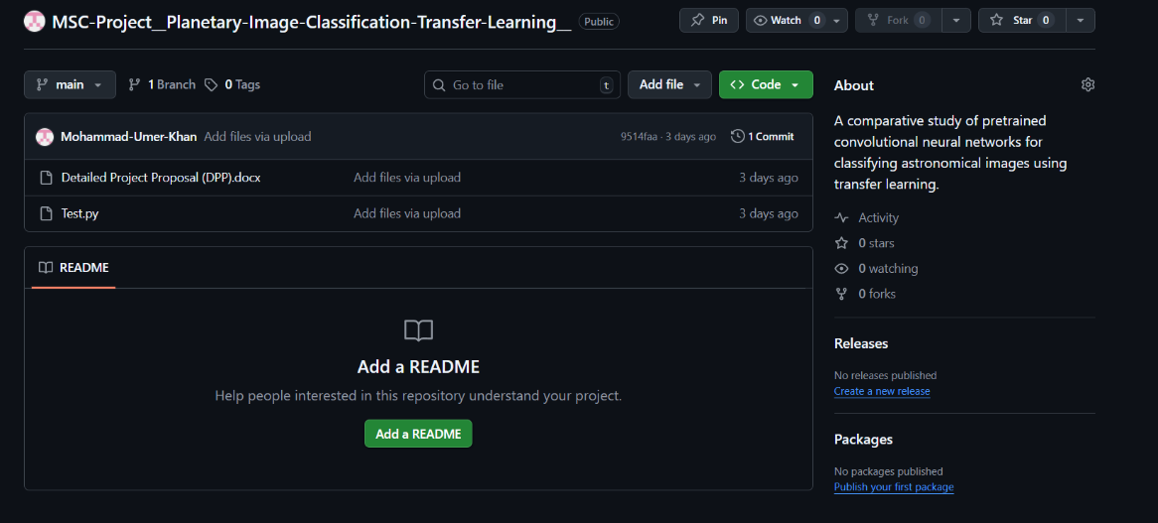
Figure 1 GitHub Repository

Appendix B: Dataset Structure
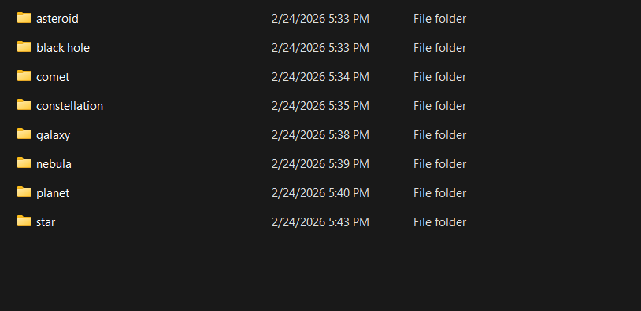
Figure 2 Dataset

Appendix C: Baseline Model Configuration and Outputs
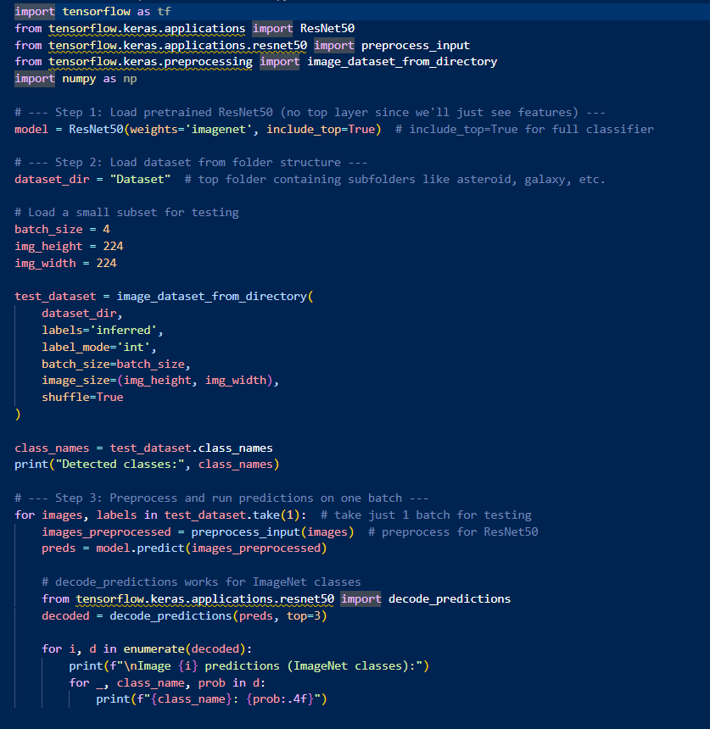
Figure 3 Baseline Code Attempt

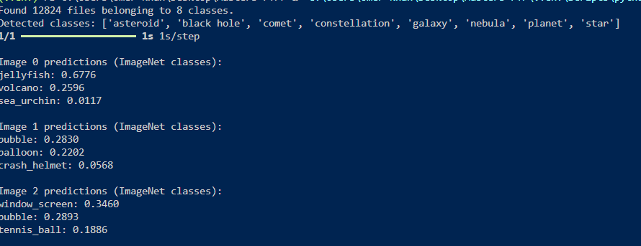
Figure 4 Baseline Code Attempt Results

Appendix G: Project Planning and Gantt Chart
This appendix includes the project timeline visualization used to manage scope, time, and dependencies. It reflects the project’s status at the time of submission.

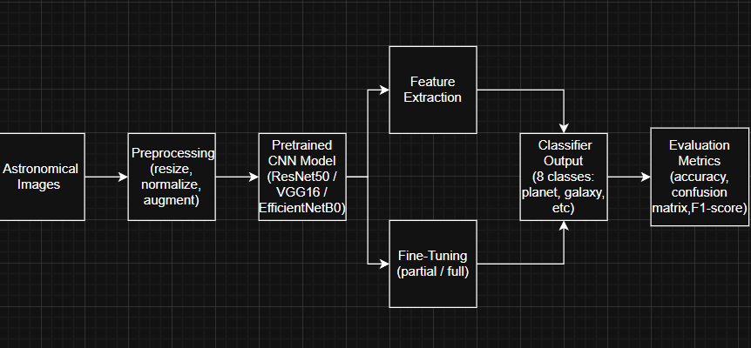
Figure 5 Project Planning Flow Chart

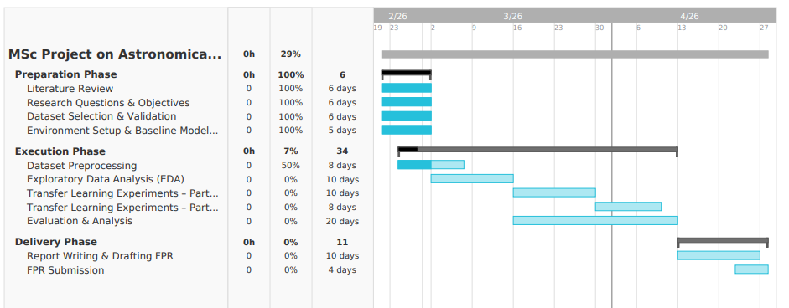
Figure 6 Gantt Chart

